EXERCISE #8 – LAB SUMMARY
NAME: _____________________________
LAB DAY __________ TIME __________

Mitosis

    - Match the following labels (A-F) in the provided images of mitosis in whitefish blastula to these structures: Nucleus, cell membrane, replicated chromosomes composed of chromatids, centrioles/aster, spindle fibers, cleavage furrow

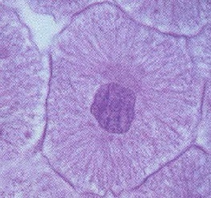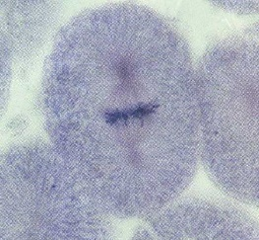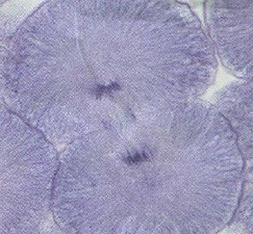
A
F
C
B
E
D

A: C: E:

B: D: F:

Match the following labels (A-F) in the provided images of mitosis in Allium root tip to these structures: Nucleus, nucleolus, cell wall, replicated chromosomes composed of chromatids, spindle fibers, cell plate

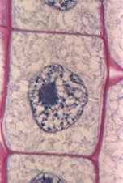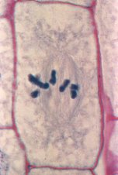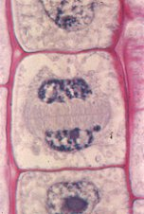
D
A
B
C
E
F

A: C: E:

B: D: F:

    - Observe the stages of mitosis in the prepared slides of whitefish blastula and Alium root tip. Count 20 mitotic cells on each slide, determine the frequency of each phase. Frequency = # cells in given stage/ total # cells in view x 100%. (Eg. 2 cells in telophase/20 x 100% = 10%)
Animal
Interphase Prophase Metaphase Anaphase Telophase
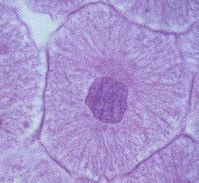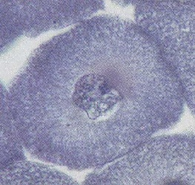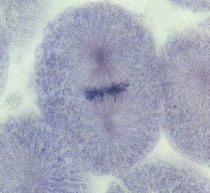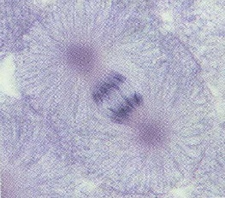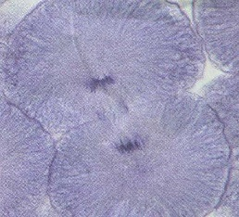

Plant
Interphase Prophase Metaphase Anaphase Telophase
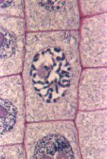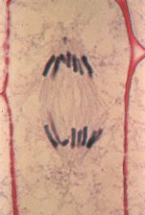

  - Based on your calculations (from Q #1b), which stage of the cell cycle probably takes the longest amount of time?

  - How does telophase differ between animal and plant cells?

Karyotyping
Go to the following URL: http://www.biology.arizona.edu/cell_bio/tutorials/meiosis/main.html for an interactive activity that will help you answer questions 4-16.
Once you have logged onto the University of Arizona Site. Please click on "Chromosomes in a diploid cell” (on the left side) and read the short section labeled, "Karyotyping".
  - What is a karyotype (look at the bulleted items below the word karyotype)?

Karyotype section - Karyotyping activity:
Now click on the word “Karyotype”
  - G banding refers to the type of dye used in staining chromosomes. Identify this dye? _________________
  - This dye binds to regions of the chromosome that are rich in what two base pairs or nucleotides?
    - ___________________________________________
    - ___________________________________________
  - Does a band only contain one gene? ________________________________________________________
  - Karyotyping involves matching chromosomes based on three characteristics, what are they?
    - __________________________________________________________________________________
    - __________________________________________________________________________________
    - __________________________________________________________________________________
After answering the previous questions, scroll down to the bottom of the screen and click on the "Patient Histories" button. This takes you to the patient histories page. Please click on "Complete Patient A's Karyotype" and follow the instructions on each successive web page, answering the questions below as you go

Patient A Anlysis
  - What chromosome # is the first one that you matched? _______________
  - What chromosome # is the second one that you matched? _______________
  - What chromosome # is the third one that you matched? _______________
  - What chromosome # is the fourth one that you matched? _______________
  - What extra chromosome # does this patient possess? _______________
  - Is the diagnosis monosomy or trisomy? _____________________________
  - Indicate the specific syndrome and why you came to this conclusion.

  - What is aneuploidy?

Mitotic Index and Cancer
Complete the following table using the Ex.8 PPT (slides 16-21) on Canvas.
Patient ID | # Cells in Interphase | # Cells in  Prophase | # Cells in  Metaphase | # Cells in  Anaphase | # Cells in  Telophase | Mitotic Index=  (# cells in P, M, A or T)  Total # cells
A

B

C

D

E

F

  - Which normal/healthy type of tissue sample (skin, lung or breast) had the highest mitotic index? Why do you think this is the case?

  - What do you notice between the mitotic index of patients with and without cancer regardless of tissue type? Why do you think this occurs?

  - Examine the karyotype of a cancer patient’s cell.
    - How many total chromosomes are seen in the karyotype?
    - At which positions are there too many chromosomes?
    - At which positions are there too few (or no) chromosomes?
    - Besides abnormal numbers of chromosomes, are there any other unique characteristics of the chromosomes displayed in the cancer patient’s karyotype?

End of Summary Concept Check
- Looking at the mitotic index for all 3 cancer types, which one is likely to be the most resistant (least affected) to the growth-inhibiting effects of traditional chemotherapy drugs that target rapidly dividing cells?

- A researcher is studying the effects of a novel cancer drug on cell division and comparing the new drug to a traditional chemotherapy drug. The traditional drug causes numerous side effects such as nausea, vomiting, hair loss and susceptibility to infections due to low white blood cell counts. The novel drug is a targeted therapy (specifically targets the abnormal protein in the cancer cell) and is likely to reduce side effects that patients experience when treated with traditional chemotherapy. One group of cancer patients was treated with the novel drug and a second group of cancer patients was treated with the traditional chemotherapy drug. Prior and subsequent to treatment, a mitotic index was obtained from a tumor sample from each patient as well as a bone marrow sample (bone marrow cells give rise to all blood cell types including red blood cells and white blood cells). Since this is a double-blind study (neither the patient nor the researcher knows which patients received which drug), the patient samples were labelled with the patients’ initials but no information was provided with respect to the drug each patient was receiving. Below is the data for four different patients. Mitotic index was used to measure the effectiveness of each drug treatment. Use the data below to answer the following questions:

Patient ID | MI bone marrow cells before treatment | MI bone marrow cells after treatment | MI tumor cells before treatment | MI tumor cells after treatment
MJ | 0.15 | 0.07 | 0.44 | 0.25
JS | 0.17 | 0.15 | 0.55 | 0.08
TF | 0.14 | 0.13 | 0.47 | 0.05
KR | 0.17 | 0.04 | 0.51 | 0.32

  - Which patients above do you think were treated with the traditional chemotherapy drug? Explain your answer by referencing the data provided in the table.

  - Which patient(s) do you think were treated with the novel targeted drug therapy? Explain your answer by referencing the data provided in the table.

  - Which patients would be more susceptible to contracting an infection during treatment? Why?

